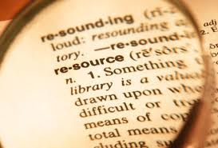
Resources request
Name | School | Just Do it! Draw it! Solve it! Explain it! Poster | SMP Poster | Ask.  Don’t tell | Other

